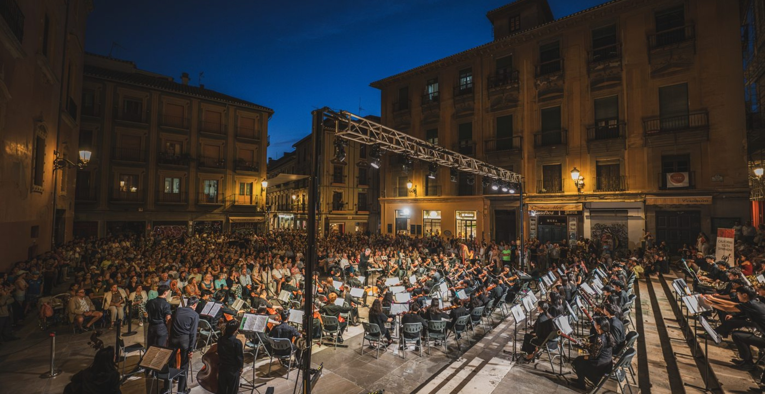

INDEPENDENT STUDY PARTICIPANT WORKBOOK
Taking Your Orchestra
on Tour
Tips, Lessons, and Inspiration from Experienced Orchestra Leaders
15 hours | 1 graduate-level professional development semester unit
One webinar plus 14 hours of assigned reading and applied planning for your ensemble.

PARTICIPANT NAME  Type here | SCHOOL / ORGANIZATION  Type here
EMAIL ADDRESS  Type here | ROLE / TITLE  Type here
DATE STARTED  Type here | DATE COMPLETED  Type here
ENSEMBLE TYPE AND GRADE/AGE RANGE  Type here | APPROXIMATE ENSEMBLE SIZE  Type here

START HERE

Course overview
This independent-study course helps orchestra and ensemble leaders turn an interest in travel into a practical, educationally grounded plan. The work is applied to your own ensemble, so the final submission should be useful whether you are exploring a first tour or strengthening an existing program.
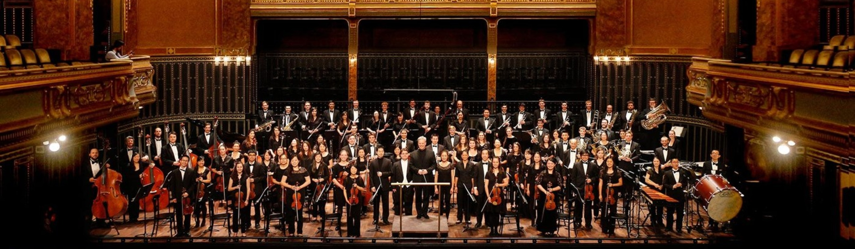
What earns the unit
Complete the one-hour opening webinar and all 14 hours of guided independent work in this workbook. Webinar attendance by itself does not earn a unit.

How the process works
- Attend the live webinar or view the Encore-approved recording.
- Complete all four assignments and the required response areas.
- Record your actual independent-study time. The assignment estimates total 14 hours.
- Upload this completed workbook through Encore’s submission form.
- If the work meets the completion criteria, Encore will issue a certificate of completion.
- Register for one unit through Courses4Teachers and attach the Encore certificate to the registration form.

Important credit information
The course is eligible for one graduate-level professional development semester unit through Courses4Teachers and University of the Pacific/Benerd College. The unit may be applicable toward salary advancement or credential renewal, but it is not applicable toward a master’s or doctoral degree through University of the Pacific. Requirements vary, so confirm acceptance and any prior-approval rules with your school district or licensing authority before registering.
Current registration information: https://courses4teachers.net/workshops-conferences-trainings-webinars/acis/

COURSE MAP

One webinar. Three readings. Four assignments.
The assigned readings are distributed across the four assignments and already included in the 14 independent-study hours. Your work may take slightly more or less time; log only the time you actually spend and complete every required deliverable.
Part | Focus | Hours | Required evidence
Webinar | Opening panel and guided reflection | 1 | Attendance or approved recording confirmation
01 | Ensemble readiness and educational goals | 3 | Readiness assessment and three goals
02 | Budget, fundraising, and accessibility | 3 | Preliminary budget and funding plan
03 | Students, families, and chaperones | 3 | Expectations, communication, and response plans
04 | Musical preparation and final tour plan | 5 | Preparation timeline and integrated plan

Learning objectives
- Assess an ensemble’s readiness for travel and define measurable musical, educational, and community goals.
- Build a preliminary financial plan that considers fundraising, access, and family resources.
- Set expectations and communication systems for students, families, chaperones, and administrators.
- Plan musical, cultural, and logistical preparation for an unfamiliar performance environment.
- Synthesize the work into a feasible next-step plan for the ensemble.
What you may use
Use your school or organization’s current policies, calendars, budgets, handbooks, and planning materials. You do not need to create new policies when an approved one already exists. Cite or attach the existing resource and explain how it applies.

COURSE READING LIBRARY

Read for application, not recall.
The readings are short Encore publications supplied with the course. You are not being tested on them. Read with your own ensemble in mind, then use the assignment prompts to turn the strongest ideas into decisions, plans, and evidence.
Reading time is included
The assigned reading below is part of the 14 independent-study hours. It is not additional work beyond the course total.

01 | Designing a Signature Orchestra Tour  A practical framework for defining intent, connecting performance and cultural goals, planning collaboration, and building a lasting program impact.

02 | The Art of Performance Programming  An editorial guide to program architecture, venue acoustics, audience awareness, emotional arc, accessibility, and memorable openings and closers.

03 | Music Educator’s Playbook  A collection of practical teaching ideas. This course uses the Student-Led Learning lesson to connect travel preparation with student voice and responsibility.

Reading plan
Part | Assigned pages | Time | Use it to
01 | Signature Orchestra Tour, pp. 2–3: Introduction and Defining the Intent | 35 min | Write an intent statement and test readiness
02 | Signature Orchestra Tour, pp. 8–9: Planning Framework and Legacy | 25 min | Strengthen the case for support and access
03 | Signature Orchestra Tour, pp. 6–7; Music Educator’s Playbook, p. 8 | 35 min | Plan student growth, voice, and group support
04 | Art of Performance Programming, pp. 2–6 and 9–11 | 65 min | Adapt repertoire and preparation to venue and audience
Access the three readings from the course page. If you print them, keep only brief notes here; you do not need to submit annotated copies.

ASSIGNMENT 01  Ensemble readiness and educational goals | 3 HOURS  Readiness assessment + goals
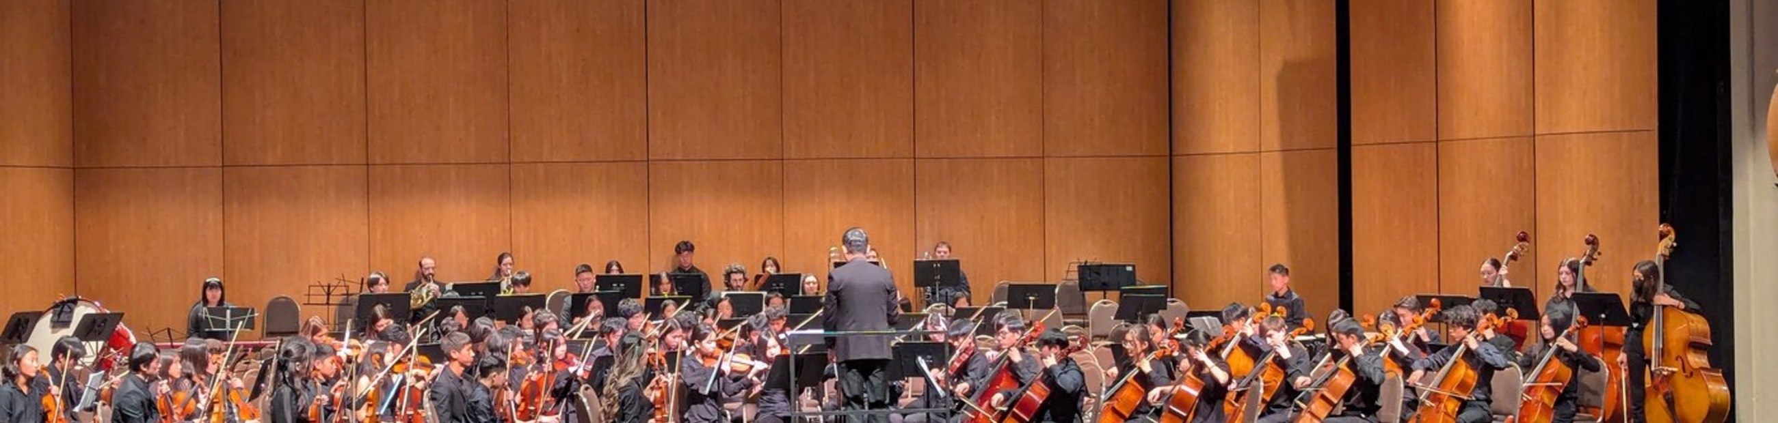

Purpose
Determine what kind of performance travel experience fits your ensemble now, what gaps must be addressed, and what educational results would make the experience worthwhile.
Assigned reading | 35 minutes
Designing a Signature Orchestra Tour, pp. 2–3: More Than a Trip. A Musical Journey. and Defining the Intent. Read for the relationship among purpose, ensemble identity, student outcomes, and early decisions.

Suggested use of time
Time | Activity | Evidence in this workbook
35 min | Complete the assigned reading and identify one planning implication. | Reading-to-practice note
20 min | Reflect on the webinar and identify the most relevant ideas. | Webinar reflection
35 min | Create a concise profile of your ensemble and travel context. | Ensemble profile
60 min | Assess readiness across seven planning areas. | Readiness matrix
30 min | Set goals and recommend a travel format or next step. | Goals and recommendation

ASSIGNMENT 01

1A. Reading and webinar reflection
First, use the reading to draft a one-sentence intent statement. Then identify three ideas from the webinar that could influence your approach to ensemble travel.
Draft tour intent statement | One early planning decision this intent should shape
What should students gain musically, culturally, and personally? | Type your response

Idea from the webinar | Why it matters for my ensemble
1. | Type your response
2. | Type your response
3. | Type your response

ASSIGNMENT 01

1B. Ensemble profile
Prompt | Your response
Ensemble and setting | School, youth, collegiate, community, or adult ensemble
Musicians | Age/grade range, size, instrumentation, and experience
Current calendar | Major performances, trips, testing, and conflicts
Prior travel | What the ensemble has or has not experienced
Decision makers | People whose support or approval is required
Opportunity under consideration | One-day performance, domestic tour, international tour, or another format

1C. Readiness assessment
Use evidence, not just instinct. For each area, record what is currently true, the most important gap or risk, and the next action that would improve readiness.
Readiness area | Current evidence | Gap or risk | Next action
Musical readiness
Student maturity
Family interest and support
Administrative support
Financial capacity and access
Staffing and chaperones
Planning timeline

ASSIGNMENT 01

1D. Goals and recommendation
Write three goals that are specific enough to guide decisions. Include at least one musical goal and one student-development or community goal.
Goal | What success would look like | How we would know
1.
2.
3.

Recommended next step
Select the option that best fits your current evidence and explain your recommendation.
☐ One-day performance | ☐ Domestic tour | ☐ International tour | ☐ Build readiness first
Recommendation and rationale
Use evidence from the readiness assessment and connect the recommendation to your goals.
Three actions to take in the next 90 days
1.
2.
3.

ASSIGNMENT 02  Budget, fundraising, and accessibility | 3 HOURS  Preliminary financial plan
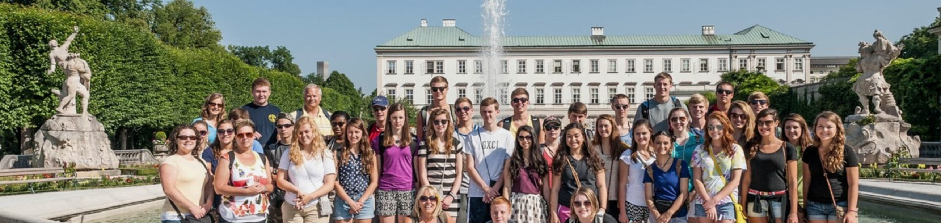

Purpose
Create an early financial framework that is realistic enough for discussion and flexible enough to refine after you receive an actual program proposal.
Use planning figures, not invented precision
If you do not have vendor pricing, state your assumptions and use reasonable planning ranges. The goal is to identify the major cost drivers, funding gap, and access strategy.

Assigned reading | 25 minutes
Designing a Signature Orchestra Tour, pp. 8–9: A Thoughtful Planning Framework and From Experience to Legacy. Read for the timing, outcomes, and program benefits that can strengthen your case for support.

Suggested use of time
- 25 minutes: complete the assigned reading and record one useful implication.
- 25 minutes: define participant, timing, and pricing assumptions.
- 55 minutes: create a preliminary budget and per-participant estimate.
- 45 minutes: build a fundraising and scholarship plan.
- 30 minutes: identify access concerns and messages for key stakeholders.

Reading-to-practice note
Which planning principle or program benefit from the reading should shape your financial case?
Name the idea and explain how it applies to your ensemble.

2A. Planning assumptions
Assumption | Working figure or explanation
Travel format and destination
Proposed season or dates
Estimated student participants
Estimated adults/chaperones
Planning price per participant
Students expected to need support | Number or percentage, if known
Key assumption or uncertainty

ASSIGNMENT 02

2B. Preliminary budget
Use total figures, per-person figures, or both. Mark items that are already included in a proposed program price.
Budget category | Assumption or source | Estimated total ($) | Per person ($)
Tour/program package
Air or ground transportation
Meals not included
Insurance/protection
Tips and local expenses
Equipment/instrument needs
Contingency
Scholarship/access reserve
TOTAL

2C. Funding plan
Funding source or activity | Owner | Timing | Expected net ($) | Access consideration

ASSIGNMENT 02

2D. Access and stakeholder support
A strong plan explains both how the experience will be funded and how students with different financial circumstances can participate.

Access strategy
Question | Your response
How will need be identified respectfully?
What scholarships, payment options, or community support could be available?
How will fundraising benefit the whole group while addressing individual need?
What financial threshold or condition would make the plan unworkable?

Your case for support
Draft a short explanation for an administrator, board member, family, or donor. Connect the educational value to the financial plan and name the specific support you are requesting.
150–250 word draft
Type your draft here.

ASSIGNMENT 03  Students, families, and chaperones | 3 HOURS  People + communication plan
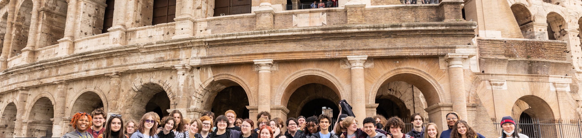

Purpose
Plan the human side of travel: clear expectations, appropriate supervision, timely communication, and a response framework for common issues on the road.
Your policies come first
Use the approved policies and emergency procedures of your school or organization. This workbook supports planning but does not replace those requirements.

Assigned reading | 35 minutes
Designing a Signature Orchestra Tour, pp. 6–7: Collaboration, Workshops & Exchange and Cultural Immersion & Student Growth; plus Music Educator’s Playbook, p. 8: Student-Led Learning. Read for student voice, responsibility, intercultural learning, and group connection.

Suggested use of time
- 35 minutes: complete the assigned reading and record one useful implication.
- 35 minutes: define student and family expectations.
- 40 minutes: assign chaperone roles and escalation responsibilities.
- 35 minutes: build a communication timeline.
- 35 minutes: respond to two realistic travel scenarios.

Reading-to-practice note
How could students take meaningful ownership before, during, or after the tour?
Identify one authentic responsibility and the adult support it would require.

3A. Student and family expectations
Area | Expectation or standard | How and when it will be communicated
Participation and eligibility
Rehearsal and preparation
Conduct and digital behavior
Attendance and punctuality
Health, medication, and accessibility
Financial commitments and deadlines

ASSIGNMENT 03

3B. Chaperone and supervision plan
Role or responsibility | Primary owner | Backup | Brief protocol
Attendance and head counts
Rooming and curfew
Medication/health process
Student behavior
Transportation transitions
Family communication
Emergency escalation

3C. Communication timeline
Milestone | Audience | Message or decision | Channel/owner
Initial interest
Approval/launch
Registration
Payment milestones
Final preparation
During and after travel

ASSIGNMENT 03

3D. Preparing for issues on the road
Choose two scenarios. For each, explain the immediate response, who must be notified, which policy or resource applies, and one preventive step. Do not include confidential student information.
- A student becomes ill shortly before a scheduled performance.
- A student repeatedly misses meeting times and delays the group.
- Homesickness or peer conflict begins affecting participation.
- A student loses a phone, identification document, or essential item.
- A chaperone disagrees with the director’s response to a student issue.
Scenario 1 selected | Immediate response | Notification and policy | Prevention

Scenario 2 selected | Immediate response | Notification and policy | Prevention

Communication principle
What do students, families, and chaperones need to understand before departure so your responses are clear and consistent?
Type your response here.

ASSIGNMENT 04  Musical preparation and final tour plan | 5 HOURS  Preparation plan + capstone
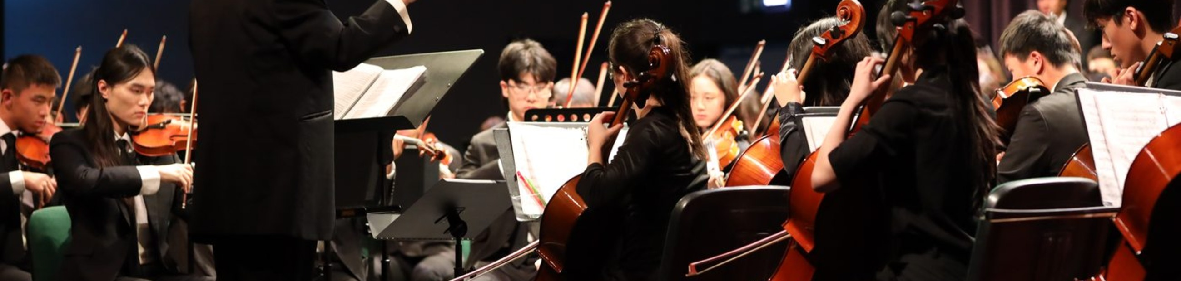

Purpose
Translate the preceding work into musical preparation, student learning, an implementation timeline, and a concise plan you could share with decision makers.
Assigned reading | 65 minutes
The Art of Performance Programming, pp. 2–6 and 9–11. Focus on program architecture, emotional arc, concert-hall acoustics, audience accessibility, memorable closers, and the qualities shared by effective programs.

Suggested use of time
- 65 minutes: complete the assigned reading and record one programming implication.
- 75 minutes: design a rehearsal and performance-readiness plan.
- 55 minutes: plan venue preparation and a student cultural-learning activity.
- 40 minutes: build an implementation timeline.
- 65 minutes: write the integrated tour plan and final reflection.

Reading-to-practice note
What should change in your repertoire, sequencing, rehearsal priorities, or audience preparation because of the venue?
Name one reading insight and the practical adjustment it suggests.

ASSIGNMENT 04

4A. Rehearsal and performance readiness
Build a six-to-eight-week preparation sequence. Adapt the number of weeks to your ensemble calendar.
Week(s) | Musical focus | Student responsibility | Evidence/checkpoint

ASSIGNMENT 04

4B. Preparing for the performance environment
Question | Your response
What will be unfamiliar about the venue or performance setting?
How will you prepare students for acoustics, staging, timing, or etiquette?
What repertoire or programming considerations matter?
How will you gather and apply clinician or audience feedback?

4C. Student learning beyond the stage
Design one student-facing activity that connects the performance experience to musical, historical, cultural, or community learning.
Activity element | Plan
Learning objective
Before travel | What students will investigate or prepare
During travel | What students will observe, discuss, or document
After travel | How students will reflect or demonstrate learning
Evidence of learning

ASSIGNMENT 04

4D. Implementation timeline
List the decisions, approvals, communications, financial milestones, and preparation work needed at each stage. If your timeline is shorter, adapt the phases.
Phase | Key actions and decisions | Owner(s) | Evidence of completion
12+ months
9–12 months
6–9 months
3–6 months
Final 90 days
After travel
Keep it practical
Your plan does not need every logistical detail. It should make the next decisions visible, assign responsibility, and show how musical, financial, and student goals stay connected.

ASSIGNMENT 04 CAPSTONE

4E. My orchestra tour plan
Write a concise plan that another decision maker could understand without reading the entire workbook. Address all of the prompts below in approximately 600–900 words.
- Why this experience matters and which students or musicians it serves
- The recommended travel format, timing, and performance opportunity
- The three principal musical, educational, or community goals
- The financial framework, fundraising approach, and access strategy
- How students, families, chaperones, and administrators will be prepared
- How the ensemble will prepare musically and learn beyond the stage
- The three most important next actions
Integrated plan
Type your 600–900 word plan here. Add pages if needed.

FINAL REFLECTION

What changed in your thinking?
Reflection question | Your response
Which assumption about ensemble travel did this course strengthen or challenge?
What is now the strongest reason to move forward, pause, or change direction?
Where do you still need information or support?
What will you do within the next 30 days?

Completion review
Encore reviews submissions for completion, specificity, feasibility, connection to course goals, and evidence of thoughtful reflection. Work is marked complete or returned for revision; there is no letter grade.
A revision is not a failure
If a section is incomplete or too general to demonstrate the required work, Encore may ask you to revise it before issuing the certificate.

REQUIRED RECORD

Independent-study time log
Record the time you actually spend on assigned reading and the four applied assignments. Do not include the one-hour webinar in this table. The independent-study total must equal at least 14 hours.
Date | Activity | Start/end or duration | Hours | Evidence/notes
TOTAL INDEPENDENT-STUDY HOURS | __________ / 14 minimum

FINISH AND SUBMIT

Completion checklist
☐ I completed the opening webinar or Encore-approved recording.
☐ I completed all assigned readings and the reading-to-practice notes.
☐ I completed all four assignments and every required response area.
☐ My final integrated plan is included.
☐ My time log records at least 14 hours of independent study.
☐ I removed confidential student information from the workbook.
☐ I saved the file as LastName_FirstName_OrchestraTour_Workbook.docx or PDF.

Participant attestation
I certify that this submission represents my own work and that the time log is an accurate record of the professional-development time I completed. I understand that Encore may request revisions or supporting information before issuing a certificate of completion.
PARTICIPANT SIGNATURE OR TYPED NAME | DATE
SCHOOL / ORGANIZATION | EMAIL

Submit your workbook
Encore course submission form
Upload this completed workbook through the submission form provided in your Encore course instructions.

After approval, Encore will email your certificate of completion. You will then register for one unit through Courses4Teachers and attach the certificate to the registration form. Registration fees and district requirements are separate from Encore’s completion review.
Questions about the workbook or submission process? encoretours@acis.com

